**ApoA4 information**:

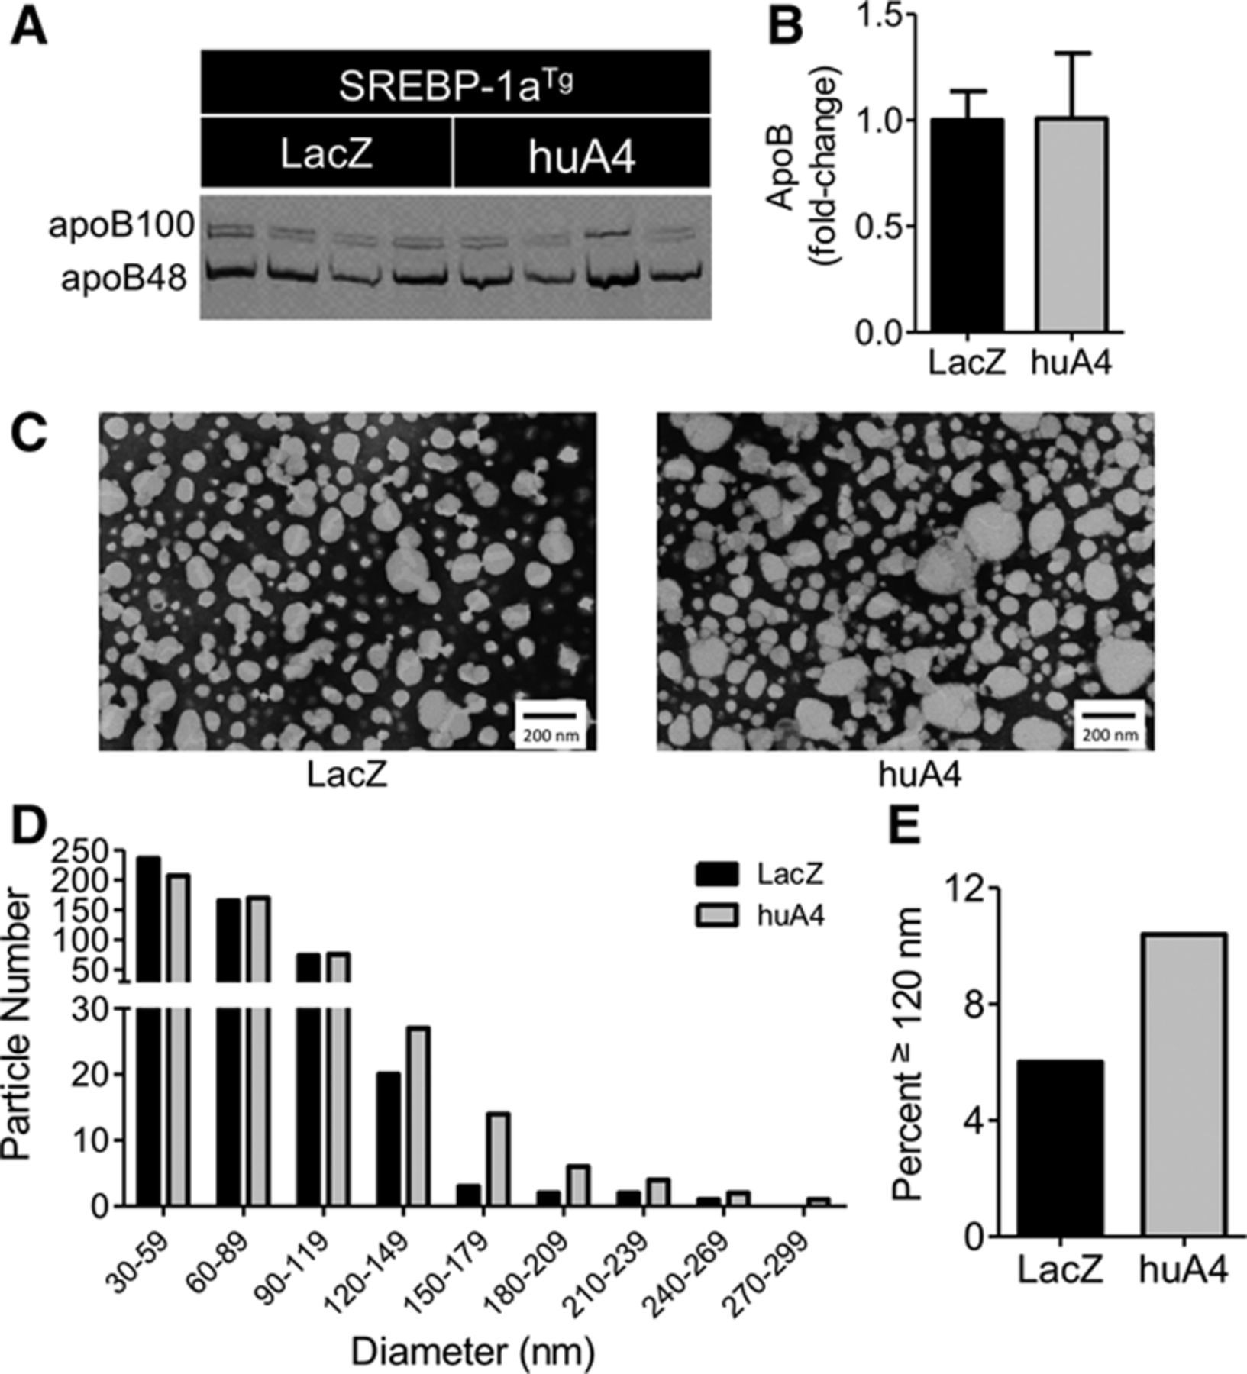

(VerHague, et al., 2013)

Overexpression of ApoA-IV increases V-LDL particle size in the blood of mice. No ApoB secretion, meaning the number of particles stayed the same. ApoA4 upregulated.

ApoIV knockout and overexpression fail to influence triglyceride absorption in intestine. However the overexpression paper used a transgene of human ApoAIV, maybe some positional effect that cause this to not match the phenotype. Fat levels in plasma not changed by ApoAIV KO.

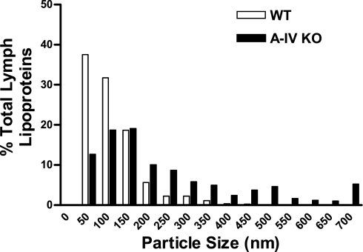

(Kohan et al., 2011)

KO also increases Chylomicron size?? But from different tissue: lymph vs blood.

Protein is expressed more in intestine in 2021 Trujillo-Vero paper, but not mRNA.

|  |  |  |  |  |  |
| --- | --- | --- | --- | --- | --- |
| Source | Chylomicron Phentoype | ApoB, protein levels | Lipid Phenotype | Genotype | Tissue/Organism/Fast |
| Kohan et. al 2011 | Increased Chylomicron size | Less ApoB | Lower lipid levels in plasma, no adiposity or weight change | *Apoa4* KO | Mouse, lymph, 5h fast |
| Verhauge et. al 2013 | Increased Chylomicron Size | Less ApoB | Higher Triglycerides in plasma | *Apoa4* OE human | Mouse, Blood |
| Verhauge et. al 2013 | Reduced Chylomicron size | More ApoB | Slightly lower triglycerides in plasma | SB-TG: x Apoa4 KO | Mouse, Blood |
| Nhan Presentation | No change |  |  | *Apoa4b.1*  OE | Zebrafish, whole larvae, no feeding ever |
| Nhan Presentation | No change | Less ApoB |  | *Apoa4a* KO | Zebrafish, whole larvae, no feeding ever |
| Trujillo-Vero et. al 2021 | Smaller Chylomicrons. More APOA4 protein in intestine | No Change | Lower triglycerides in plasma, lower weight, more robust insulin response | *Prkd2* KO | Mice, intestine |
| Weinstock et al. 1997 | Lower VLDL levels |  | Reduced plasma triglyceride levels, no weight change, no apidosity change | *Apoa4* KO | Mice, blood, 18h fast |

Weinstock and Kohan note decreased ApoC-III expression because gene is adjacent to ApoAIV.